WEEK 1
Program 1

<!DOCTYPE html>
<html>
<head>
<title>Social Media Dashboard - Program 1</title>
<style>
body { background-color:#eef7ff; font-family:Arial; }
h1 { text-align:center; color:#1877f2; }
table { border-collapse:collapse; width:70%; margin:auto; }
th, td { border:1px solid black; padding:8px; text-align:center; }
th { background-color:#1877f2; color:white; }
</style>
</head>

<body>

<h1>Social Media Dashboard</h1>

<h2>User Profile</h2>
<ul>
<li>Name: Arjun</li>
<li>Followers: 1500</li>
<li>Following: 400</li>
<li>Platform: InstaConnect</li>
</ul>

<h2>Daily Activities</h2>
<ol>
<li>Login</li>
<li>Upload Post</li>
<li>Like Posts</li>
<li>Comment</li>
<li>Logout</li>
</ol>

<h2>Post Statistics</h2>
<table>
<tr>
<th>Post ID</th>
<th>Likes</th>
<th>Comments</th>
<th>Shares</th>
</tr>

<tr>
<td>201</td>
<td>320</td>
<td>45</td>
<td>20</td>
</tr>

<tr>
<td>202</td>
<td>210</td>
<td>30</td>
<td>10</td>
</tr>
</table>

</body>
</html>

Program 2
<!DOCTYPE html>
<html>
<head>
<title>Social Media Dashboard</title>

<style>
body {
margin: 0;
font-family: Arial;
background-color: #eef6ff;
}

/* Header */
header {
background-color: #1877f2;
color: white;
padding: 15px;
text-align: center;
}

/* Navigation */
nav {
background-color: #ffffff;
padding: 10px;
text-align: center;
}

nav a {
text-decoration: none;
margin: 10px;
padding: 8px 15px;
background-color: #1877f2;
color: white;
border-radius: 5px;
}

/* Sections */
section {
display: none;
padding: 20px;
margin: 20px;
background-color: white;
border-radius: 8px;
}

/* Active Section */
section:target {
display: block;
}

/* Forms */
input, select, textarea {
width: 100%;
padding: 6px;
margin-bottom: 10px;
}

button {
padding: 8px;
background-color: #1877f2;
color: white;
border: none;
width: 100%;
}

/* Table */
table {
width: 100%;
border-collapse: collapse;
}

th, td {
border: 1px solid black;
padding: 8px;
text-align: center;
}

th {
background-color: #1877f2;
color: white;
}
</style>
</head>

<body>

<header>
<h1>Social Media Dashboard</h1>
</header>

<nav>
<a href="#home">Home</a>
<a href="#login">Login</a>
<a href="#catalogue">User Stats</a>
<a href="#register">Register</a>
</nav>

<!-- HOME SECTION -->
<section id="home">
<h2>Welcome to ConnectHub</h2>
<p>This is a simple social media dashboard created using HTML and CSS.</p>
</section>

<!-- LOGIN SECTION -->
<section id="login">
<h2>Login</h2>
<form>
Username:
<input type="text" required>

Password:
<input type="password" required>

<button type="submit">Login</button>
</form>
</section>

<!-- CATALOGUE SECTION -->
<section id="catalogue">
<h2>User Statistics</h2>

<table>
<tr>
<th>User ID</th>
<th>Name</th>
<th>Followers</th>
</tr>

<tr>
<td>1</td>
<td>Arjun</td>
<td>1500</td>
</tr>

<tr>
<td>2</td>
<td>Meena</td>
<td>1800</td>
</tr>

<tr>
<td>3</td>
<td>Rahul</td>
<td>1200</td>
</tr>
</table>
</section>

<!-- REGISTER SECTION -->
<section id="register">
<h2>Create Account</h2>

<form>
Name:
<input type="text" required>

Email:
<input type="email" required>

Gender:
<input type="radio" name="g" required> Male
<input type="radio" name="g"> Female
<br><br>

Address:
<textarea rows="3" required></textarea>

<button type="submit">Register</button>
</form>
</section>

</body>
</html>

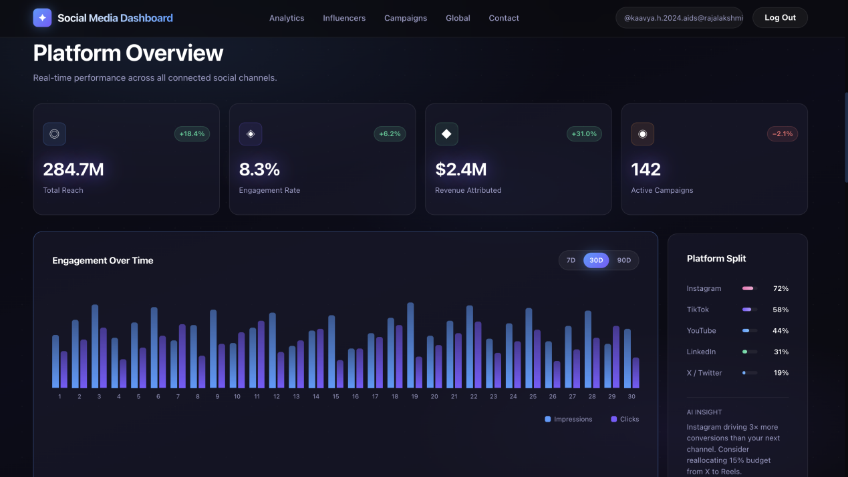
Program 3
<!DOCTYPE html>
<html>
<head>
<title>Program 3 - Media Viewer</title>

<style>
body {
font-family: Arial;
background-color: #eef6ff;
text-align: center;
}

h1 {
color: #1877f2;
}

a {
background-color: #1877f2;
color: white;
padding: 8px 15px;
text-decoration: none;
border-radius: 5px;
}

iframe {
margin-top: 20px;
width: 500px;
height: 250px;
border: 2px solid #1877f2;
}
</style>

</head>
<body>

<h1>Social Media Banner Viewer</h1>

<a href="https://via.placeholder.com/500x250" target="frame1">
Click to Load Banner
</a>

<br><br>

<iframe name="frame1"></iframe>

</body>
</html>


Program 4
<!DOCTYPE html>
<html>
<head>
<title>Program 4 - Registration Form</title>

<style>
body {
background-color: #e6f2ff;
font-family: Arial;
}

form {
background-color: white;
width: 350px;
margin: 50px auto;
padding: 20px;
border-radius: 8px;
}

h2 {
text-align: center;
color: #1877f2;
}

input, select, textarea {
width: 100%;
padding: 6px;
margin-bottom: 10px;
}

button {
width: 100%;
padding: 8px;
background-color: #1877f2;
color: white;
border: none;
}
</style>

</head>
<body>

<form>
<h2>Create Account</h2>

Name:
<input type="text" placeholder="Enter your name" required>

Email:
<input type="email" placeholder="Enter your email" required>

Platform:
<select required>
<option>Instagram</option>
<option>Facebook</option>
<option>Twitter</option>
</select>

Gender:
<input type="radio" name="gender" required> Male
<input type="radio" name="gender"> Female
<br><br>

Address:
<textarea rows="3" placeholder="Enter address" required></textarea>

<button type="submit">Register</button>
<button type="reset">Reset</button>

</form>

</body>
</html>

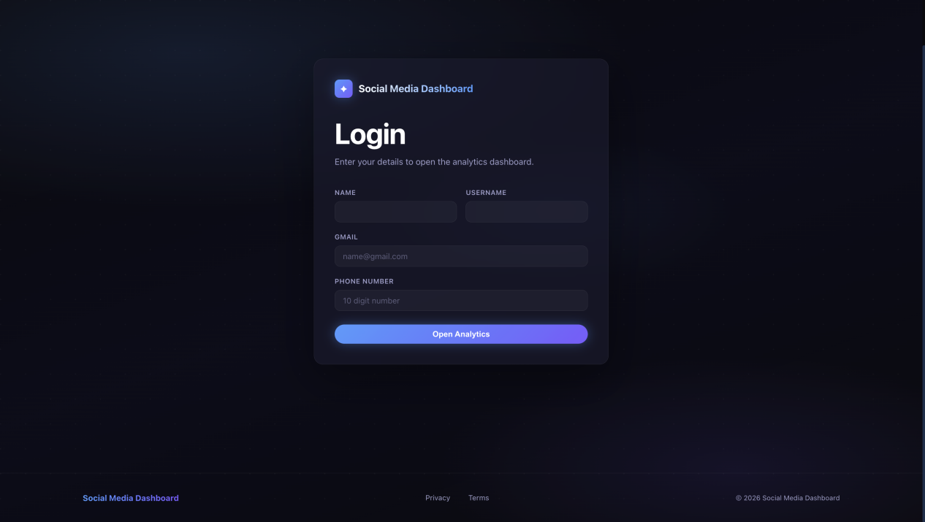

Program 5
<!DOCTYPE html>
<html>
<head>
<title>Program 5 - Social Media Map</title>

<style>
body {
text-align: center;
font-family: Arial;
background-color: #f0f8ff;
}

h1 {
color: #1877f2;
}
</style>

</head>
<body>

<h1>Social Media Global Reach</h1>

<!-- Local image instead of online link -->
<img src="worldmap.jpg"
usemap="#socialmap"
width="600"
height="350"
alt="World Map">

<map name="socialmap">

<area shape="rect"
coords="50,50,200,200"
href="#"
onclick="alert('Asia Users: 5 Million')">

<area shape="rect"
coords="300,50,550,200"
href="#"
onclick="alert('USA Users: 3 Million')">

</map>

</body>
</html>

